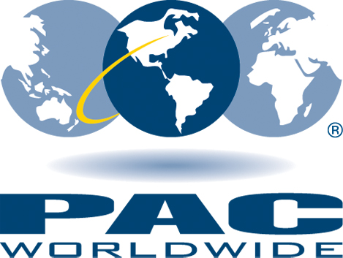
For Immediate Release 9 a.m. PST
August 6th 2015

CONTACT: Erin Smith
Digital Content Manager
PAC Worldwide
425-202-4026
Erin.Smith@pac.com

PAC Worldwide Corporation Releases the New
Mailer vs. Box Dimensional Weight Calculator Tool on www.pac.com

REDMOND,WA — August 6th 2015 — PAC Worldwide has recently released the Mailer vs. Box web application. This cost-savings and dimensional weight tool can be found at www.pac.com/mailervsbox.

The Mailer vs. Box tool allows users to input the dimensions of the product they are shipping to their customers, which results in a comprehensive comparison between shipping in a poly bubble mailer vs. a corrugated box with dunnage. Users will be presented with a direct price comparison, savings per package, saving per month, savings per year, along with freight/warehouse space and environment impact comparisons.

This tool takes it one step further than your average dimensional weight calculator by demonstrating the amount of semi-trailer truck space required to ship the poly bubble mailers vs. corrugated boxes, the space/pallets needed to store them in a warehouse, as well as a comprehensive environmental comparison.

“We are very excited about the Mailer vs. Box app on www.pac.com/mailervsbox. In January 2015, ALL packages shipped through UPS or Fedex are subject to dimensional (DIM) weight pricing. This change has drastically increased the cost of shipping for many retailers still using boxes to ship their products. DIM weight alone can cause a cost increase - but then you factor in over-packaging your product, using packaging that is too large, warehouse and truck space, the costs really add up. If you’re able to ship your product in a poly bubble mailer instead of a box with dunnage, you’ll save on shipping costs and packaging costs (corrugated box, air pillows, packaging tape versus a bubble mailer), you will also have less packaging waste, and a smaller impact on the environment. We hope this tool serves to help retailers faced with these new increased shipping costs to find the best solution to save money.” - Erin Smith, Digital Content Manager.

About PAC Worldwide Corporation
PAC Worldwide, an industry leader and manufacturer of protective flexible packaging, has built their business up since 1975 based on outstanding service and quality products. This international company specializes in custom branded and stock mailers (bubble, flat poly, paperboard), flexible pouches, industrial and retail bubble, security bags, folding cartons and automated bags, and many other types of specialty packaging. They also offer a full line of fulfillment services as well as automated packaging systems for high speed applications.
#########

For more information, press only:
Erin Smith, 425-202-4026, erin.smith@pac.com

